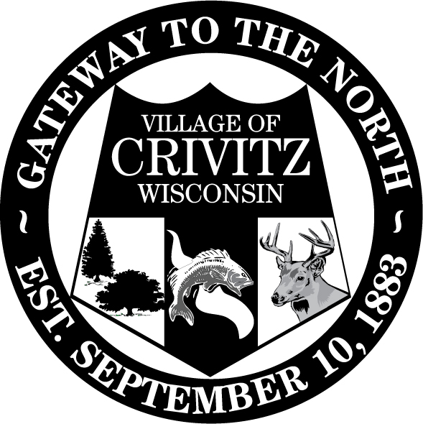
Village of Crivitz Phone (715)854-2030
800 Henriette Ave. Fax (715)854-2748

P.O. Box 727 e-mail: emoser@crivitz.gov

Crivitz, WI 54114

Visit us on the web at www.villageofcrivitz.com
*********************************************************************************************
NOTICE OF REGULAR BOARD MEETING: ***AMENDED***
Notice is hereby given that a regular meeting of the Board of Trustees of the Village of Crivitz will be held on Wednesday, November 27, 2024 at 6:00pm in the boardroom of the Crivitz Village Hall located at 800 Henriette Ave., Crivitz, WI 54114. This meeting will be held in person and remotely by video & teleconference; access instructions appear below. Meeting materials may be obtained by contacting the Crivitz Village Clerk by email or at the phone number above.

Zoom Meeting: https://us02web.zoom.us/j/89919172746?pwd=QUtIY0tpUkkxM3hyVXRxVlpoWXVsQT09

Phone Number: +1 312 626 6799
Meeting ID: 899 1917 2746
Passcode: 147823
One tap mobile: +13126266799,,89919172746#,,,,*147823#

MEETING AGENDA INCLUDES
- Call to Order
- Roll Call
- Adoption of Agenda
- Consent Agenda (Minutes, Vouchers, etc.)
- Committee & Attorney Reports
- Comments from preregistered citizens
- Nick Lakari
- Certified Survey Map Robert Street
- Certified Survey Map Kenny Drive
- 9th Alley Abandonment
- Handbook Changes- Clerk residency requirements
- Handbook Changes- Clerk education requirements
- Mausoleum Sale
- December meeting date change
- Water tower tree cutting
- Deputy clerk/treasurer position
- Street Use Permit
- ***2025 Budget***

Old Business

New Business

Correspondence

Questions from the Floor:

Please note that, upon reasonable notice at least 24 hours in advance, efforts will be made to accommodate the needs of disabled individuals through appropriate aids and services. For additional information to request this service, please contact the Village Clerk's Office at (715)854-2030, 800 Henriette Ave., P.O. Box 727, Crivitz, WI 54114.

Dated this 25th of November, 2024
Elizabeth K. Moser
Clerk/Treasurer

